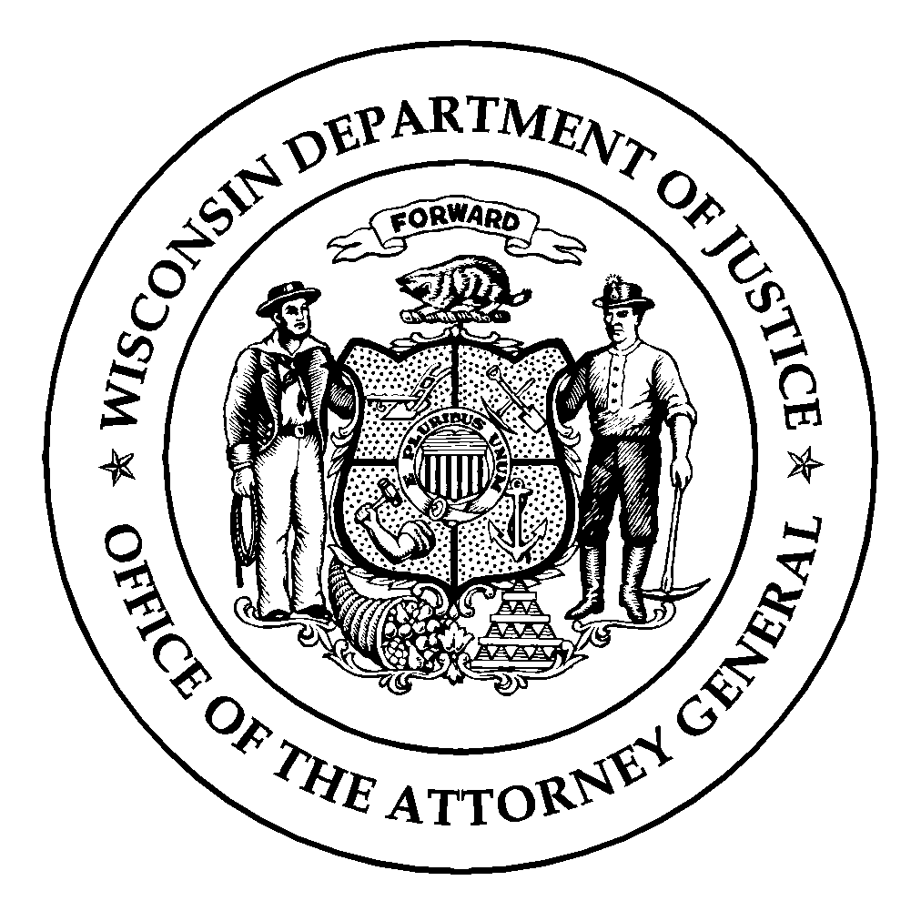Wisconsin Department of Justice
Law Enforcement Standards Board
DJ-LE-336, Rev. 06/23
https://wilenet.widoj.gov/

INSTRUCTOR TRAINING COURSE APPLICATION
LESB-APPROVED TOPIC-SPECIFIC INSTRUCTOR COURSES

To be eligible for instructor certification with the Law Enforcement Standards Board (LESB) in any of the following topics: Defensive & Arrest Tactics (DAAT), Defensive Tactics (DT), Emergency Vehicle Operation & Control (EVOC), Handgun and Rifle, Principles of Subject Control (POSC), Professional Communication Skills (PCS), Standardized Field Sobriety Testing (SFST), Tactical Response, Scenarios, Vehicle Contacts, and/or Tactical Emergency Casualty Care for Law Enforcement Officers (TECCLEO), a LESB-approved Topic-Specific Instructor Course must be completed.

This form must be signed and dated by both the applicant and the applicant’s employer (agency administrator). Return this to the training school in advance of admission to a LESB-approved Topic-Specific Instructor Course.

Last Name | First Name | Middle Initial
Credential ID (8 digits) | Employer
Topic Specific Instructor Course (i.e., DAAT) | Dates of Topic Specific Instructor Course (m/d/yy – m/d/yy)

Instructor Development Course (Check the box that applies to you)

Exempt – I am currently a LESB-certified instructor seeking additional certification in a new topic area.
(Attach a copy of your Acadis Training History Report showing current instructor certification along with a completed form DJ-LE-310, Student Release of Information)

I completed the 32-Hour Criminal Justice Instructor Development Course (CJIDC) within the past two (2) years and I am not currently a LESB certified instructor. Date Completed:
(Attach a copy of your CJIDC Course Completion Certificate along with a completed form DJ-LE-310, Student Release of Information)

Exempt – I am licensed by the Wisconsin Department of Health Services as an EMS Instructor II, and I am applying to attend the Tactical Emergency Casualty Care for Law Enforcement Officers (TECCLEO) instructor course. (Attach a copy of your instructor license along with a completed form DJ-LE-310, Student Release of Information)

Exempt – I wish to complete the Physical Fitness Assessor Instructor Course and receive credentialing as Physical Fitness Assessor with the LESB.

None of the above. If none of the above apply you are not eligible to take part in a LESB-approved Topic Specific Instructor Course.

Occupational & Educational Experience (Check all of the boxes that apply to you)

I have acquired 2.5 years of full-time, or at least 5,000 hours of occupational experience as a certified law enforcement officer, have a minimum of 60 associate degree level college credits or higher, and wish to complete one of the following LESB-approved Topic Specific Instructor Courses: DAAT, DT, EVOC, Firearms, PCS, SFST, TECCLEO, Tactical Response, Scenario, or Vehicle Contacts.

I am licensed by the Wisconsin Department of Health Services (DHS) as an EMT basic or higher and certified by DHS as an EMS Instructor II, or licensed as a DHS EMT basic or higher and certified with the LESB as a General Law Enforcement Instructor, and I am applying to attend the TECCLEO Instructor Course. (Attach a copy of your DHS license)

I have acquired 2.5 years of full-time, or at least 5,000 hours occupational experience as a certified jail officer or secure juvenile detention officer and wish to complete the LESB-approved PCS or DT Instructor Course.

None of the above. If none of the above apply, you are not eligible to take part in a LESB-approved Topic Specific Instructor Course.

Pre-Course Requirements (Check the box that applies to you)

I am applying to attend a topic specific instructor course. I understand that I may be required to demonstrate skills proficiency and/or knowledge on the first day of the course. If I am unable to show proficiency and knowledge in the subject, I will not be permitted to continue in the instructor course.

I affirm that the information provided above is both true and accurate.

Applicant’s Signature Date

Agency Administrator’s Signature Date

Instructor related questions may be directed to Thessa Phillips at (608) 267-1931. Questions related to the law enforcement curriculum may be directed to Stephanie Pederson at (608) 261-8641. Questions related to the jail and/or secure juvenile detention curriculum may be directed to Michelle Sandry at (608) 267-1327.

